**Vehicle Sales Over the Years: Ford Escape, Honda Pilot, and Volvo XC90**

Heidi Rogers and Olivia Bojesen

**Introduction**

In this study we investigated the historic car sales patterns for the Ford Escape, Honda Pilot, and Volvo XC90 and used this data to predict future sales. We gathered data on the US sales figures from the Goodcarbadcar website (*2022 US Vehicle Sales Figures by Model*, 2022) which included the number of sales each month from January 2005 to October 2022. Within the last 17 years, Ford Escape sales averaged at 18,628 per month, Honda Escape at 10,202, and Volvo XC90 at 1,929.

**Methods**

All data was analyzed using R 4.2.1 (R Core Team, 2022). We plotted our data to visualize and compare sales patterns for each vehicle and identify any trends over the last 17 years. In order to forecast what future sales might look like, we created a time series model for our data. To do this, we used all but the last six months of sales data to build three different types of models, and compared the six-month forecast based on those models to the actual last six months of data. This method was used for each of our three cars. Using fit metrics such as RMSE and MAPE, as well as visual comparison, we determined the most accurate model to use on our vehicles which looked at average values, trend over time, and cyclical behavior in sales. Our selected time-series model was fit to the entirety of our data for each car, and we observed the forecasts for the next 12 months and next 10 years.

**Results**

Ford Escape sales peaked in February of 2012 with a total of 37,332 sales recorded that month yet have been steadily decreasing within the last decade. Honda Pilot sales peaked in July of 2006, with a total of 19,490 sales that month. Sales for this car have also peaked in 2012, 2017, and 2021, but have maintained a fairly steady average. Sales for the Volvo XC90 peaked recently in January of 2021, with 4,943 sales that month. This car experienced a steep drop in sales in 2008, hitting its lowest point in 2015 with 13 sales, before rising again shortly after. All three vehicles experienced a sharp drop in sales in March and April of 2020 immediately following the start of the COVID-19 pandemic, but soon after returned to sales numbers more closely resembling those before the pandemic. The trends discussed are displayed in the plots below.

**

On a smaller scale, each car’s sales numbers have a pattern to them within each year, where some months frequently have higher or lower sales than others. This seasonality can be seen in the repeated amplitude changes within the years in the plots above, with possible influences being rise and fall of sale prices, new model releases, or other circumstances. All three cars have their lowest number of sales in January. The Ford Escape has its greatest number of sales in May and both the Honda Pilot and Volvo XC90 have their highest sales numbers in December. The similarities in yearly patterns between these three may represent a commonality across many types of vehicle sales. The Volvo XC90 has the least amount of variability from the mean sales overall, but this variability has increased since 2015.

The forecasted sales for each car for the next 12 months and 10 years are displayed below to show how the sales trend might continue based on our model. In the following plots, the black line represents sales from January 2005 to October 2022, the blue line represents the forecasted sales trend for different lengths of time, and the shading around the blue line shows the first and second standard deviations from the mean of the forecasted sales.

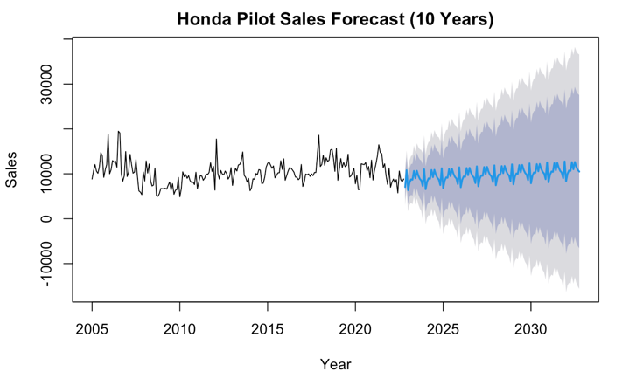

Based on the Ford Escape Sales plot for the next 12 months, sales are expected to continue decreasing overall, with seasonal upticks. The 12-month forecasts in the Honda Pilot and Volvo XC90 Sales plots stay consistent with the existing overall trend, but the highs and lows caused by seasonality don’t have as much amplitude as in the previous years. The reliability of these forecasts goes down with time. The trend lines for each car become repetitive after a year because of a lack of new sales data to forecast from and standard deviation increases as our confidence in the forecast decreases. This indicates that the true future sales numbers may have increasing variance from the forecasted line and the forecasts for these longer time periods are not very accurate.

**References**

*2022 US Vehicle Sales Figures by Model*. GCBC. (n.d.). Retrieved November 28, 2022, from <https://www.goodcarbadcar.net/2022-us-vehicle-sales-figures-by-model/>

R Core Team (2022). R: A language and environment for statistical computing. R Foundation for

Statistical Computing, Vienna, Austria. URL <https://www.R-project.org/>